|  |
| --- |
| **[ 2ceit604 User experience design]** |
|  |

Practical: 3

**AIM: Create Sketch (low fidelity wireframe) of UI & UX design of CP-II Project.**

**GATE PASS CLIENT**



**Department of Computer Engineering/Information Technology**

1. **SignIn**

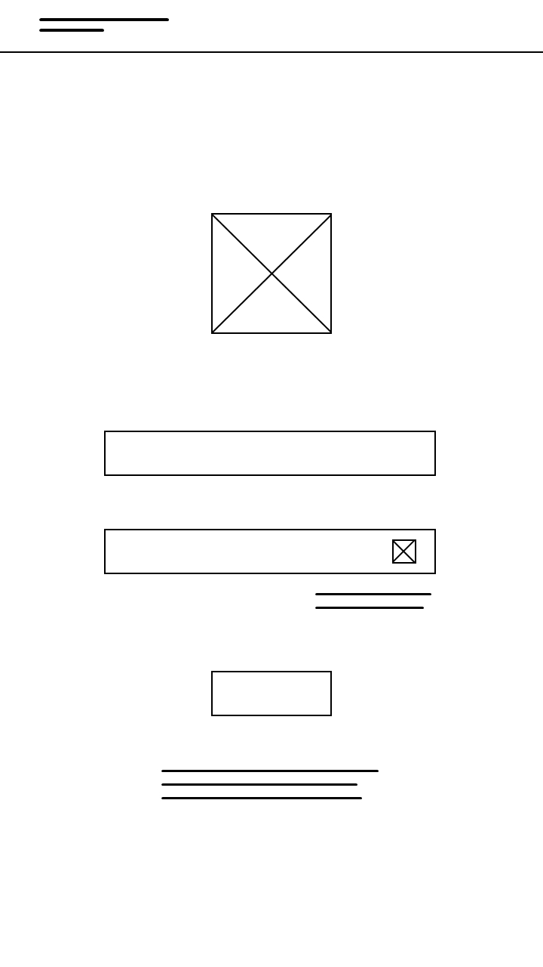

1. **SignUp**

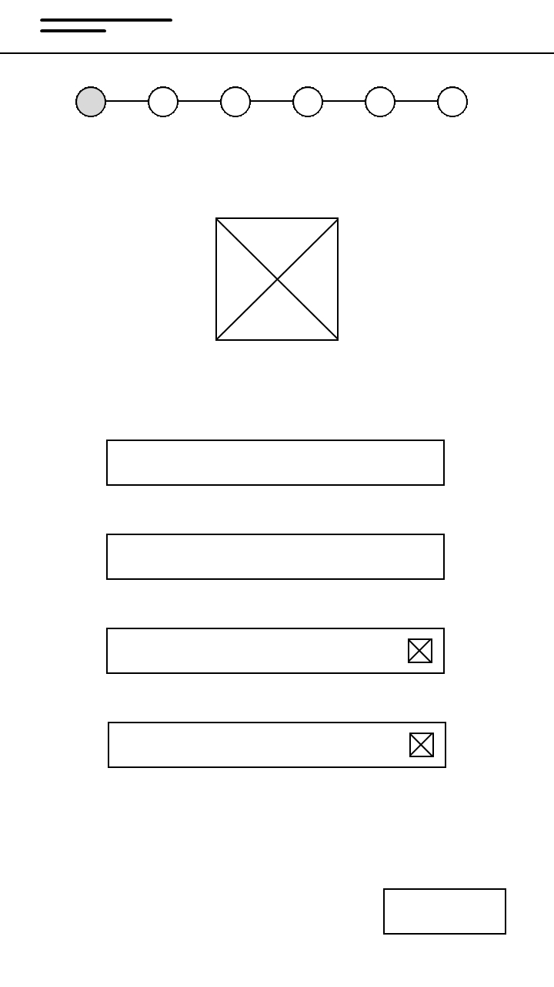

1. **SignUpVerify**

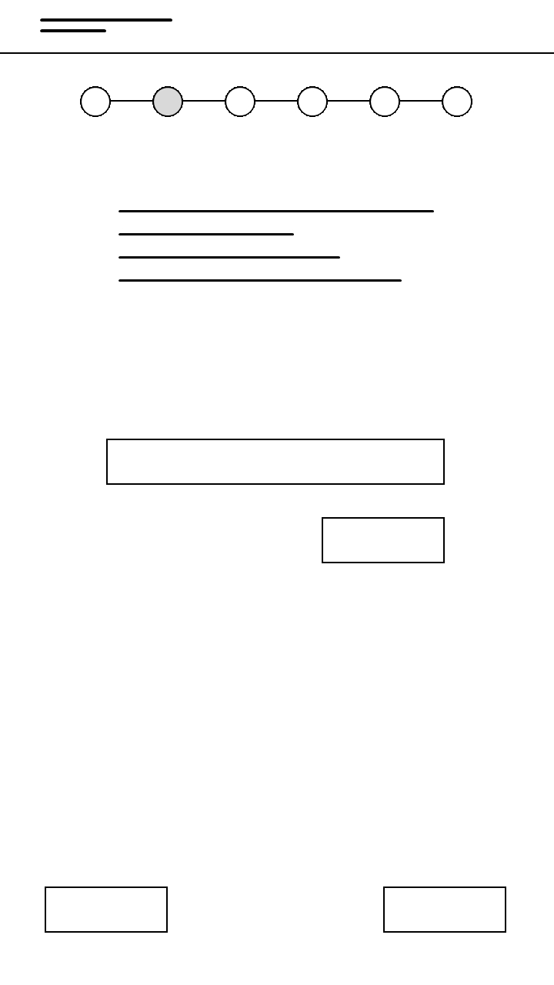

1. **Hostel Details**

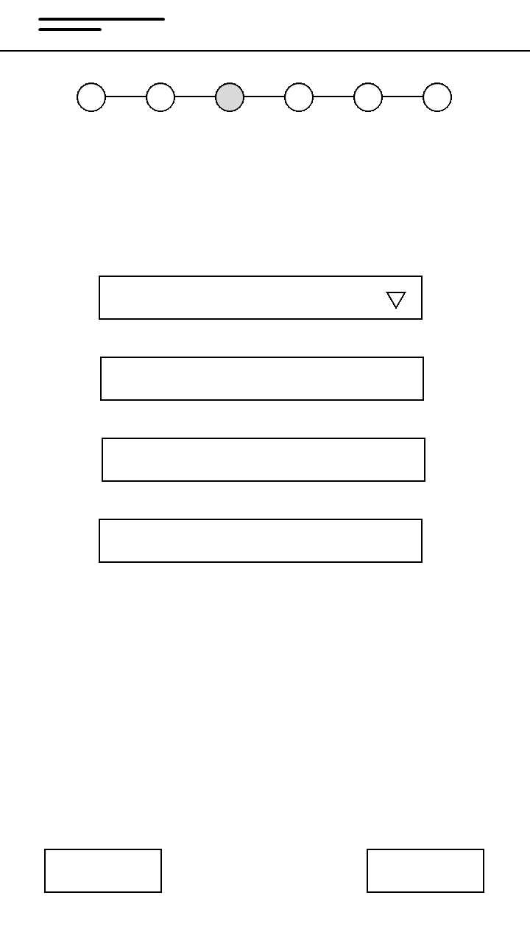

1. **Personal Details**

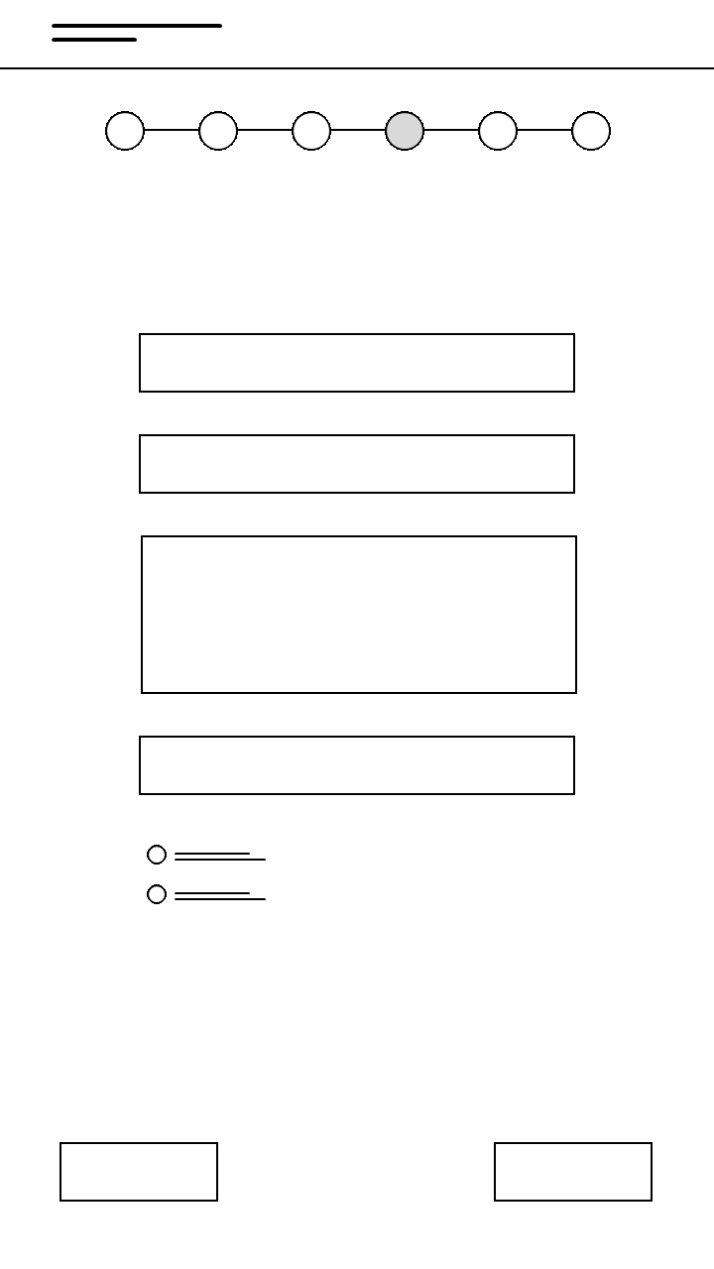

1. **Education Details**

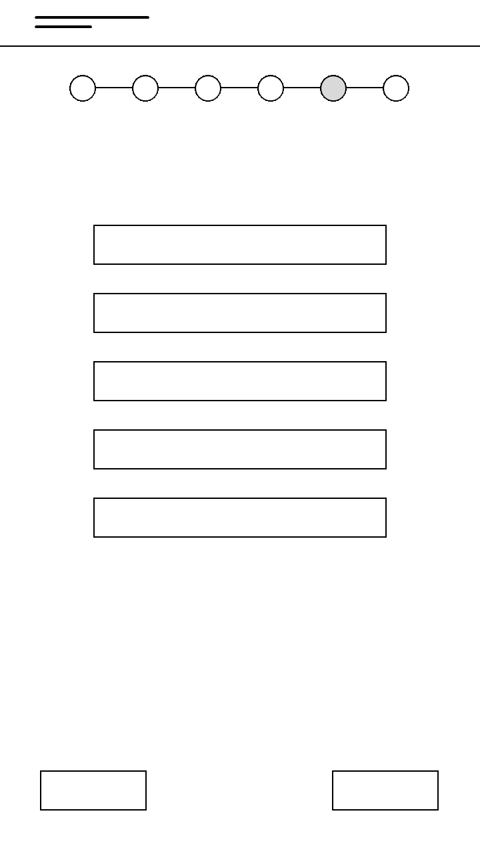

1. **Verification**

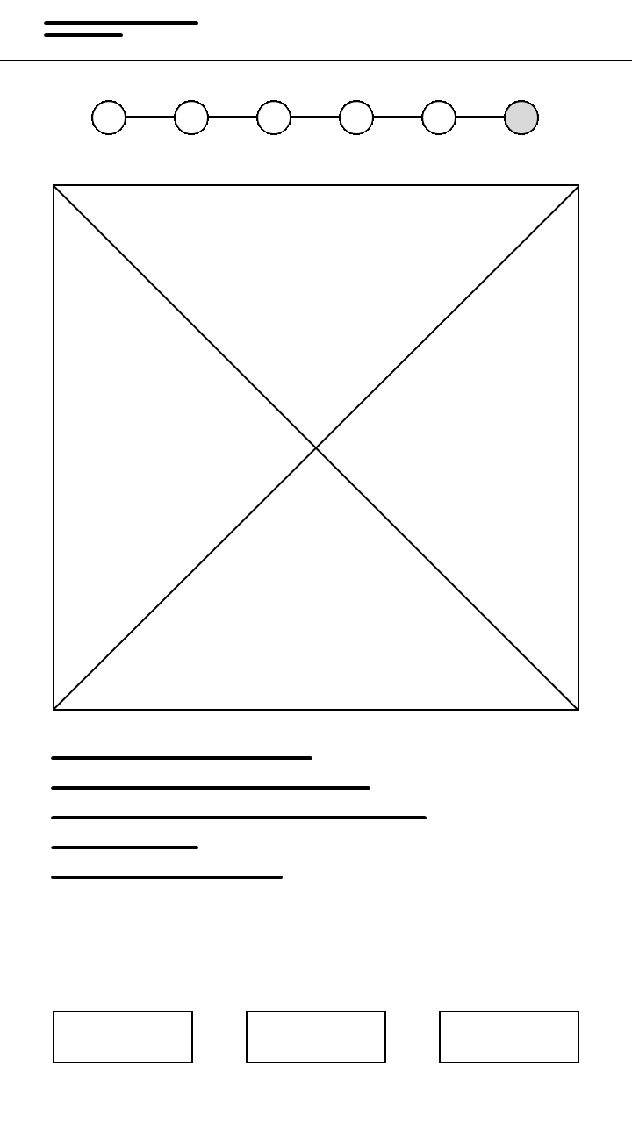

1. **Home**

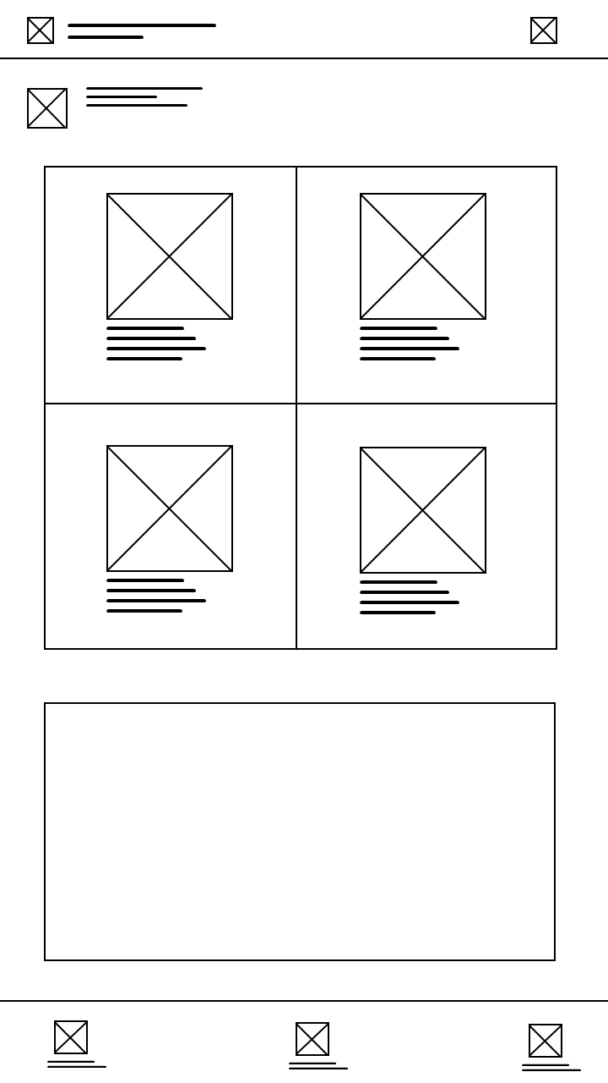

1. **CreateGatePass**

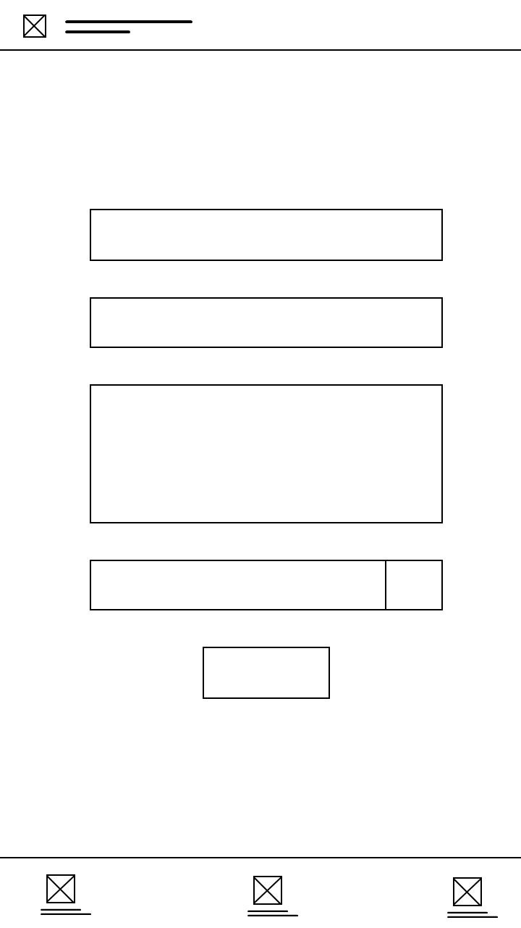

1. **History**

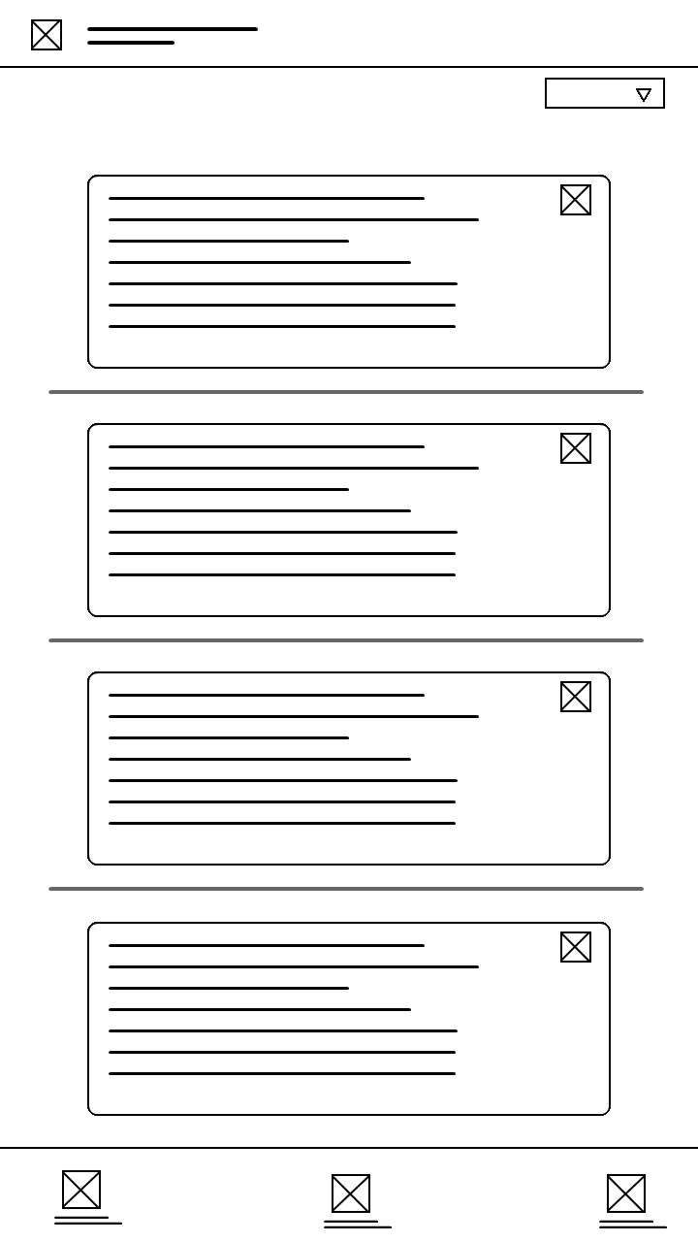

1. **GatePass Details**

